SLOVAK UNION TAEKWON-DO ITF
Ľubochnianska 5, 080 06 Ľubotice pri Prešove
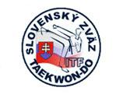
Tel.: 00421 902 899 320 www.sztkd-itf.sk IČO: 379 38 941 e-mail: euopencup@gmail.com VVS/1-900/90-22 991

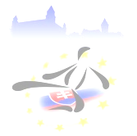
Dear Sir or Madam,

Slovak Union of Taekwon-Do ITF has the honour to invite you to the Open European Cup – Bratislava 2010 on the basis of A.E.T.F Congress decision from
23rd April 2009, Benidorm, Spain.
Open European Cup will be held in Bratislava, Slovakia from 21st to 24th October 2010 in SIBAMAC – ARENA.

Slovak Union of Teakwon-Do ITF would like to inform that the Open European Cup organised in Bratislava will be held as an open international competition with clubs and associations from other continents and will follow the ITF World Cup rules.

By participation in this competition you can represent your club, national association and country.

I hope Open European Cup will be a great opportunity and unforgettable event for all participants and will bring a lot of success which will make happy all of us.

I am looking forward to you participation

Ladislav Huňady
President
Slovak Union of Taekwon-Do ITF

www.euopencup.sk

